1. A hypodermic syringe has a plunger that is moving forward at a steady rate of 20 mm/s. Most of the fluid exits the syringe through the needle, but some leaks out the side with the plunger at a flowrate one-tenth of the flowrate of the fluid exiting through the syringe. The inside diameters of the syringe and the needle are 20 mm and 0.7 mm, respectively. Determine the average velocity of the fluid leaving through the needle.

Write out (or simply copy and paste) the original question. Include any useful graphics that may have come along with the problem.

Put your name, course, due date, and homework number in the header section of your document.

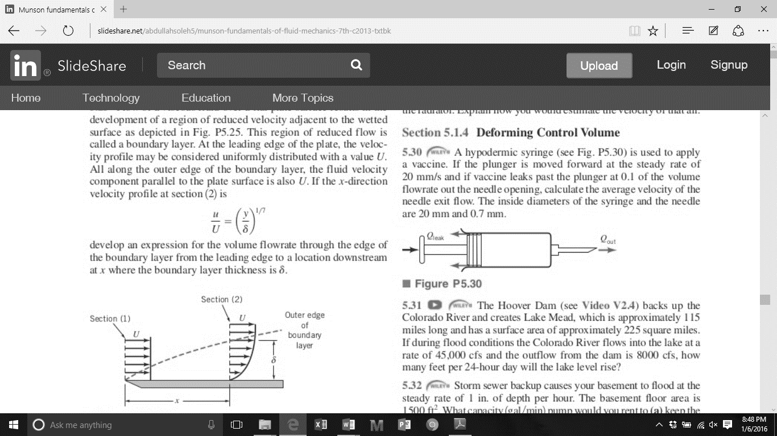

**Solution**

Assuming incompressible flow, we can perform a volume balance:

Start with any governing equation(s) (mass balance, energy balance, etc.) that may be needed to solve the problem.

Be sure to write out any assumptions you may have made when simplifying your equations.

The average velocity of the fluid leaving through the needle is equal to the volume flow rate divided by the cross-section area.

Highlight or box your final answer. (If you highlight, choose a color that still makes it easier to read the text.)

Be sure to include appropriate units and significant digits in your final answer.

Don’t forget to include units. Suggestion: write out and simplify the expression with just variables first. When you are ready to solve, then substitute your values and units.

Include page numbers (preferably showing the current page out of the total number of pages).

1. Oil steadily flows through the inclined pipe shown below. Determine the head loss over the 6-m length of pipe AND determine the direction of the flow. Explain how you determined the flow direction.

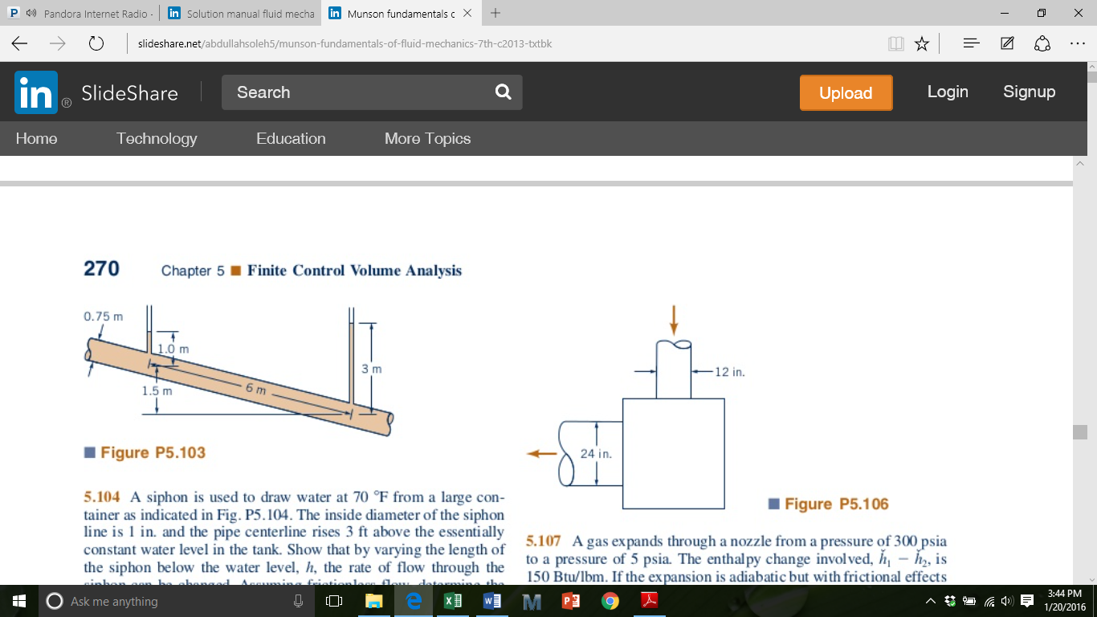

Start each new problem on a new page. Use the Insert>>”Page Break” feature to automatically start the next problem on the next page. Be sure to correctly number the problems.

**Solution**

Assume oil is flowing down to the right. We can perform an energy balance using the Bernoulli equation with the added head loss term. Since the diameter is constant and we can assume oil is incompressible, then the velocities at the upstream (1) and downstream (2) points should be the same (and thus cancel out).

Since the head loss is negative, this implies that our initial assumption about the flow is wrong and that the flow is moving **up and to the left**. Energy cannot be gained from friction. This means that point 2 (lower right) should serve as the starting point for the Bernoulli equation. The pressure at point 2 is enough to push the oil up the elevation.

If asked to explain your solution or answers, provide a concise, but reasonable and thoughtful explanation. One- or two-word replies are not acceptable.

If a question asks you to generate a plot or chart, make sure you include axes titles (and units if necessary). Provide a brief caption either before the figure or directly underneath the problem explaining what it shows.

1. A fluid with specific weight of 80 lb/ft3 and dynamic viscosity of 0.03 lb s / ft2 is contained between two infinite (into the page), horizontal parallel plates as shown below. The upper plate moves at a constant velocity of 0.02 ft/s. A pressure gradient is present in the fluid as shown by the manometer. The manometer fluid has a specific weight of 100 lb/ft3 and shows a differential reading of 0.1 in. Assuming laminar flow, determine the maximum velocity in the fluid and the location (distance from the bottom plate) of the maximum velocity.

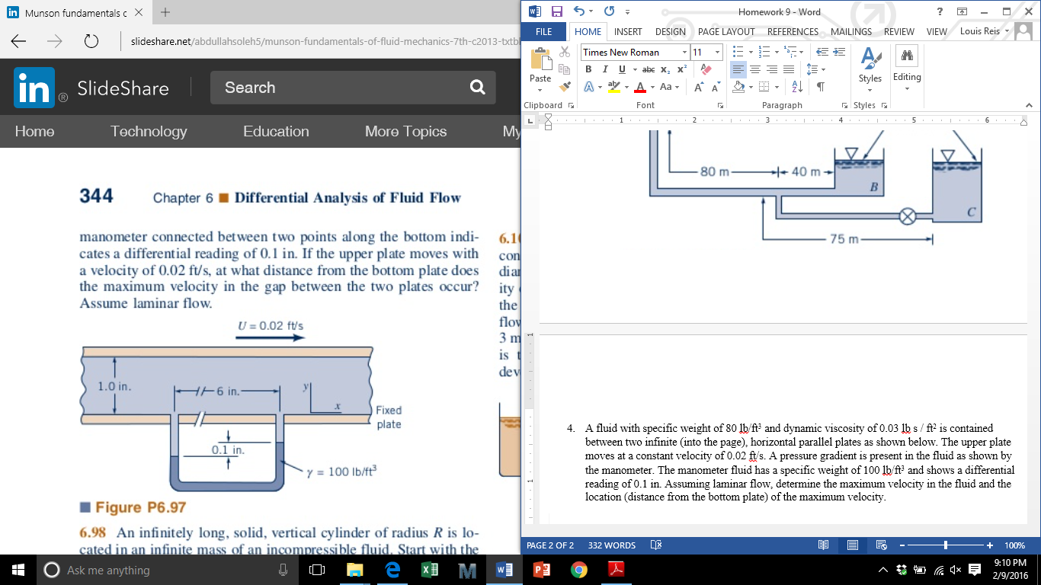

**Solution**

Using the x-component of the Navier-Stokes equation:

We will assume steady flow (), uniform flow (), no variation of flow velocity in the z-direction (, unidirectional flow (), and gravity only applies in the y-direction ().

This leaves us with:

Use Equation editor (click on “Insert” tab above and click on “Equation” on the right side) to write out your equations. Don’t scan in copies of handwritten work and don’t copy and paste Mathcad solutions (you can still use Mathcad to work out your problems, but you will need to retype the equations in Word).

If a particular letter or symbol is commonly used for a variable, then use it. If the Greek letter or symbol does not show up on the equation editor menu, then you may need to go to Insert>>Symbol and locate that Greek letter or symbol.

Shortcut: you can easily do exponents and superscripts with the “^”, and subscripts with the underscore key “_”.

Integrating once with respect to dy:

Integrating it again with respect to dy:

We will apply a no-slip condition at the bottom wall.

We can apply another no-slip condition at the top wall that is moving.

Our equation is a combination of Couette flow and Poiseuille flow.

Using the manometer, we can approximate the rate of pressure drop.

At the location where the maximum velocity is its highest, the slope (derivative) of the velocity profile (with respect to y) will be 0.

Maximum velocity will occur at y = 0.759 in measured from the bottom of the channel. We can plug this value of y back into the velocity profile equation we derived earlier to find the maximum velocity.

Overall, make sure your work looks professional (check spelling and grammar). Make it look like a “textbook solution” as if another student was reading it and trying to figure out how to solve the problem.